Documentation

While Choice is not equal to 4

Do while meters is < 0

Get Meters

Get Choice

While Choice is not equal to 4

Display menu options

Get menu option

Select Case menu option

Case 1 convert kilometers

Case 2 convert Inches

Case 3 Convert Feet

Case 4 Exit

All other cases display error message

Compile Screenshot

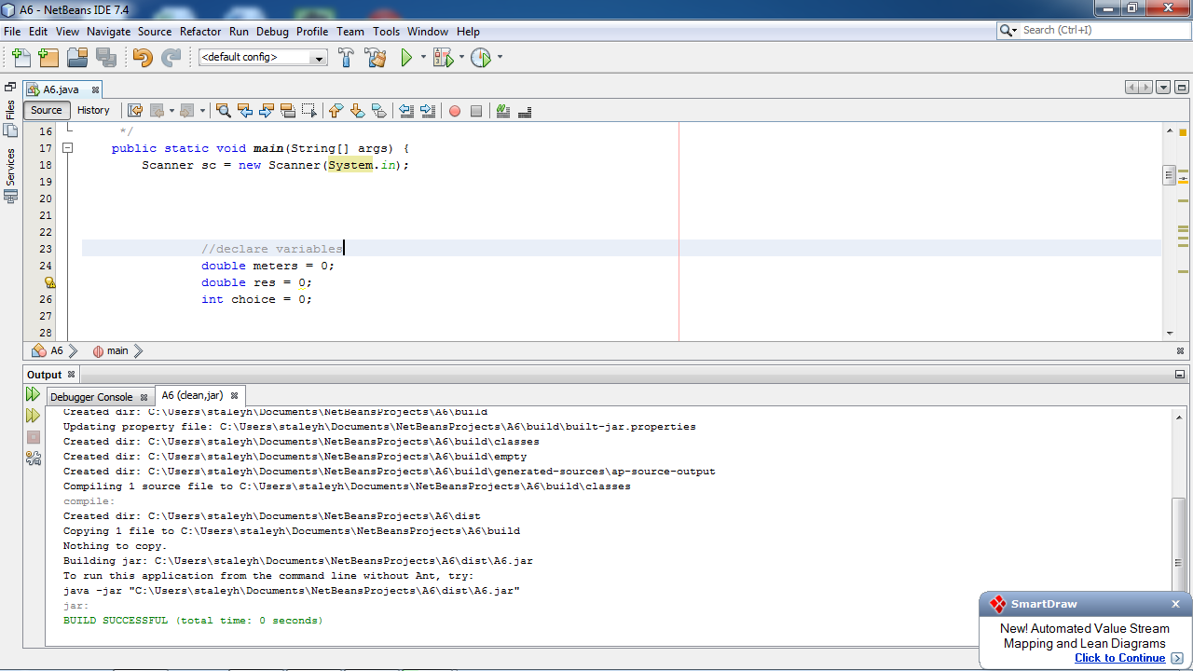

Run Screenshot

